Microchannel-Embedded 3D-Printed Ceramic Substrates for Liquid-Cooled Power Module Packaging

Haksoon Jung,¹ Seongju Kim,^{1,2} and Jimin Kwon^{1,*}

¹Department of Electrical Engineering, Ulsan National Institute of Science and Technology (UNIST),
50 UNIST-gil, Ulsan 44919, Republic of Korea
(*corresponding author email: jmkwon@unist.ac.kr)
²Department of Creative Convergence Engineering, Hanbat National University,
125 Dongseo-daero, Daejeon 34158, Republic of Korea

Novelty of work
This work introduces 3D printing of ceramic packaging substrates that co-integrates embedded microchannels for efficient liquid cooling and through-hole structures for reduced parasitic inductance, offering a co-optimized thermal–electrical solution. 250-µm through-holes, together with microchannel embedding in ceramic substrates, are experimentally demonstrated for the first time by 3D printing.

Abstract Text
The increasing demands of e-mobility, renewable energy systems, data centers, and the Internet of Things have driven the need for power devices with higher power handling capacity, improved energy efficiency, high-speed operation, and reduced form factor. Power density of power module has already exceeded 10 kVA·cm⁻³ in early 2010s and is projected to surpass 100 kVA·cm⁻³ by 2030 [1]. As power density continues to increase, managing (i) thermal dissipation and maintaining (ii) electrical signal integrity become critical challenges for reliable system operation. Heat generation in switching devices primarily arise from intrinsic power losses, especially during switching and conduction operations. Several approaches have been proposed to package devices using structures that integrate thermal management components such as heat sinks and dissipate heat by spreading concentrated heat through thermal vias. In addition, the enhanced power capacity to handle alternating current and voltage results in larger parasitic inductance and capacitance, which becomes much significant during high-speed switching. The transients can cause voltage overshoot damaging switching devices, and generating electromagnetic interference; noise in surrounding circuit components. Structures such as PCB-embedded interconnects or insertions between direct-bond copper (DBC) layers have been proposed to reduce interconnection length and mitigate parasitic transients, instead of conventional wire-bonding-based packaging. However, simple layered or embedded structures fabricated by conventional processes neccesitates additional thermal interfacial metarials (TIMs) which limits overall heat transfer efficiency between the chip and the heat sink or cold plate. In this work, we propose a microchannel-embedded, 3D-printed ceramic through-hole substrate for direct liquid cooling, which requires only a single TIM layer between the device and the cooling component. Recent advancements in 3D-printing technologies have demonstrated increasing applicability in semiconductor packaging, including surface modification [4], complex interconnect formation [5], and integration of RF components [6]. Unlike conventional wire- or ribbon-bonded packages that employ single-sided cooling and suffer from long looped interconnects and uncooled bond regions, the proposed structure enables both minimization of interconnect length and incorporation of direct liquid cooling at the chip surface, thereby realizing efficient dual-sided cooling (Figure 1b). A photocurable ceramic resin is 3D-printed to construct internal cooling channels. The through-holes for vertical electrical interconnection were uniformly fabricated within a 0.5‑mm‑thick ceramic substrate, exhibiting a diameter of 261.03 ± 7.06 µm. For mechanical stability during printing and post-processing, a 1.0‑mm‑thick supporting frame is also surrounded (Figure 1c). Post‑processing consists of debinding and sintering to produce a dense ceramic matrix. During the sintering stage, the structure undergoes dimensional shrinkage of 81.97% in the XY plane and 81.30% along the Z axis; this shrinkage is compensated for in the CAD design prior to printing to ensure dimensional accuracy of the fabricated features. Electrical metallization is achieved by electroless and electroplating following sintering. Flip-chip bonding is then used to attach a Joule-heating test die directly onto the cooling substrate, and thermal performance is assessed under various power conditions with and without liquid cooling. Trade-offs between heat dissipation and interconnect length associated with varying substrate thickness are evaluated by analyzing the increase in parasitic inductance arising from the thicker ceramic required to embed cooling channels. Thermal simulations using COMSOL Multiphysics evaluate heat dissipation performance under various cooling conditions, while CST Studio Suite extracts frequency-dependent parasitic components to analyze resonance-induced ringing behavior arising from the interaction between inductance and capacitance. The substrate with through interconnection and micro cooling channels, made possible by 3D printing, offers an advanced packaging platform that simultaneously enhances cooling efficiency and minimizes electrical interconnection length. This co-embedded configuration effectively addresses the thermal and electrical challenges inherent to high-power and high-speed operation, which are difficult to resolve using conventional layer-by-layer substrate such as DBC substrate.

References
[1] W. Saito, “A Future Outlook of Power Devices from the Viewpoint of Power Electronics Trends,” IEEE Trans Electron Devices, vol. 71, no. 3, pp. 1356–1364, 2024, doi: 10.1109/TED.2023.3332611.
[2] T. Hamieh, Z. Khatir, and A. Ibrahim, “New solution of the partial differential equation of the grain groove profile problem in the case of evaporation/condensation,” Sci Rep, vol. 9, no. 1, pp. 1–17, 2019, doi: 10.1038/s41598-019-46537-6.
[3] A. B. Jorgensen, S. Beczkowski, C. Uhrenfeldt, N. H. Petersen, S. Jorgensen, and S. Munk-Nielsen, “A Fast-Switching Integrated Full-Bridge Power Module Based on GaN eHEMT Devices,” IEEE Trans Power Electron, vol. 34, no. 3, pp. 2494–2504, 2019, doi: 10.1109/TPEL.2018.2845538.
[4] N. Kim et al., “Micro-3D-Printed Packaging Substrates With Embedded Through Holes for Organic Interposers,” in 2024 IEEE 74th Electronic Components and Technology Conference (ECTC), IEEE, May 2024, pp. 710–714. doi: 10.1109/ECTC51529.2024.00115.
[5] H. Jung et al., “3D Printed Fanout Interposer Substrates with Curved Through-Holes for Rapid Prototyping of Advanced Packaging,” 2025 IEEE 75th Electronic Components and Technology Conference (ECTC), pp. 1167–1172, 2025, doi: 10.1109/ECTC51687.2025.00201.
[6] N. Kim et al., “Quasi-Coaxial Through-Hole Integrated Additively Manufactured Antenna-in-Package Lid Substrates,” 2025 IEEE 75th Electronic Components and Technology Conference (ECTC), pp. 1779–1783, 2025, doi: 10.1109/ECTC51687.2025.00302.

Figures

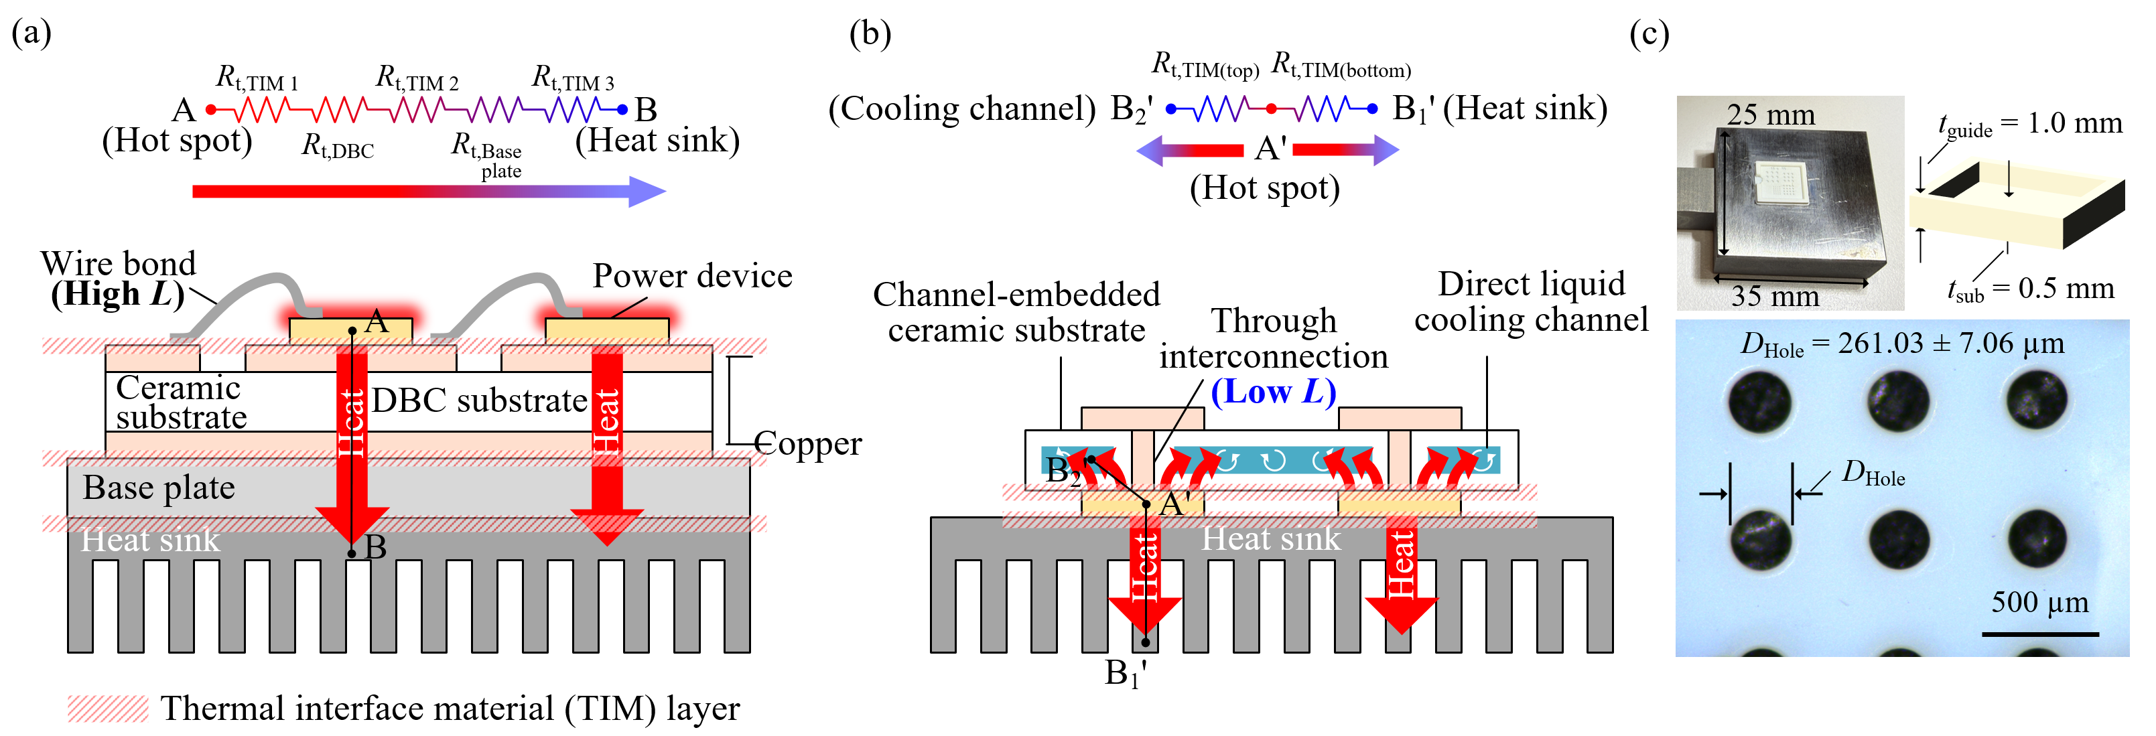
Figure 1. Ceramic substrate for hybrid dual-side cooling power device module. (a) Conventional power device module with wire bonding connection using single-side cooling. (b) Proposed power device module packaging employing 3D-printed channel embedded ceramic through-hole substrate using dual-side cooling with heat sink and direct liquid cooling channel. (c) Optical images of 3D-printed ceramic substrate with through holes for vertical interconnection.

